**COMPUTER NETWORKS**

**NAME: M.ISTAFA MALIK**

**ROLL: P190033**

**SECTION: BSCS-5A**

**Q1: What is the source and destination port numbers?**

**ANSWER:**



Source Port: = 60643

Destination Port = 80

**Q2: What is the sequence number of the TCP SYN segment that is used to initiate the TCP connection? What is it in the segment that identifies the segment as a SYN segment?**

**ANSWER:**

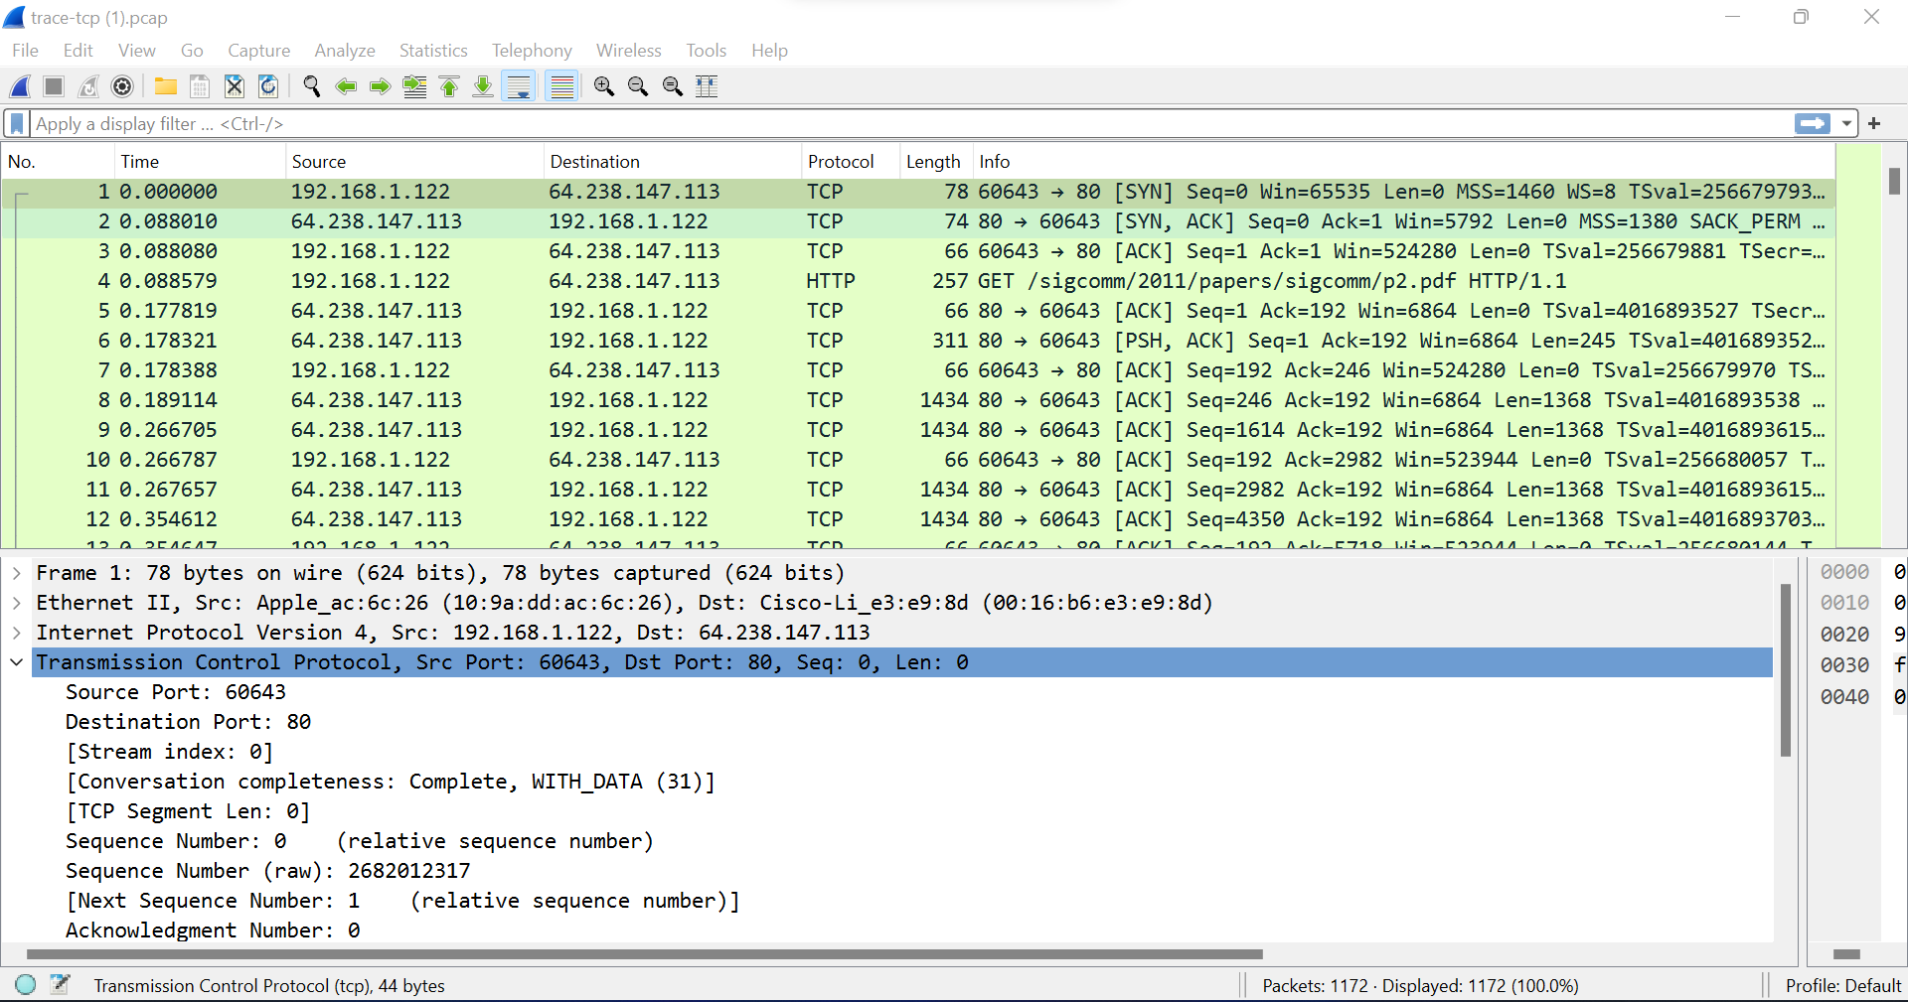

Sequence Number =2682012317

**Q3: What is the sequence number of the SYNACK segment sent by the server to the client computer in reply to the SYN? What is the value of the Acknowledgement field in the SYNACK segment? How did server determine that value? What is it in the segment that identifies the segment as a SYNACK segment?**

**ANSWER:**

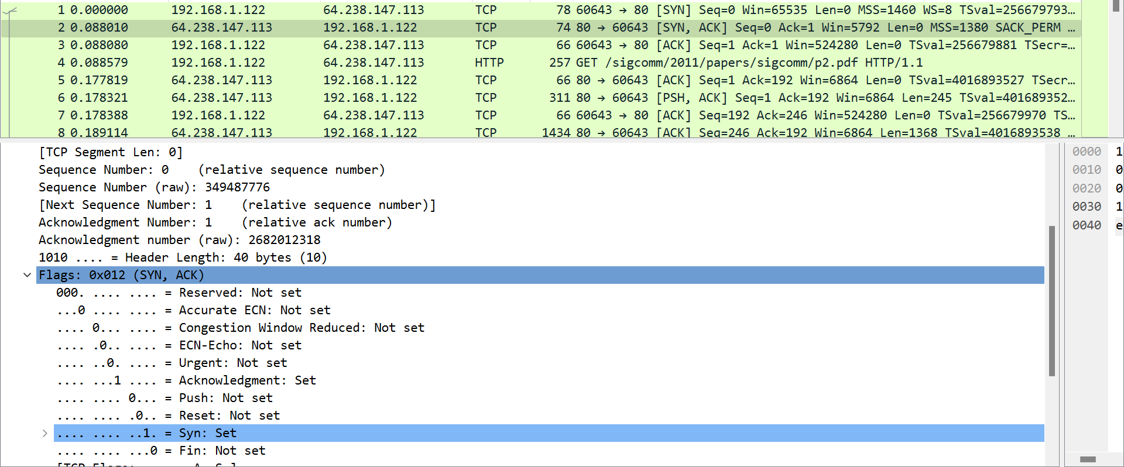

The Sequence Number is: 349487776

The acknowledgment Number is: 2682012318

The acknowledgment field's value is set in the SYNACK set. The server chooses the value for the Acknowledgement field in the SYNACK segment. The SYN segment's initial sequence number from the client computer receives an addition of 1 from the server. In this instance, the client computer's SYN segment's beginning sequence number is 0.

**Q4: What is the length of each of the first six TCP segments?**

**ANSWERS:**

**Segment 2:**

TCP segment Length: 0

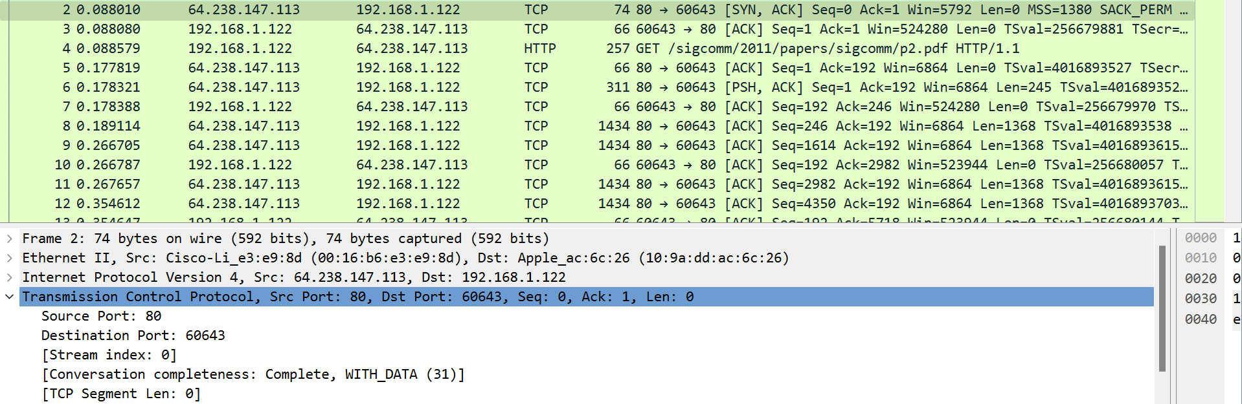

**Segment 5:**

TCP segment Length: 0

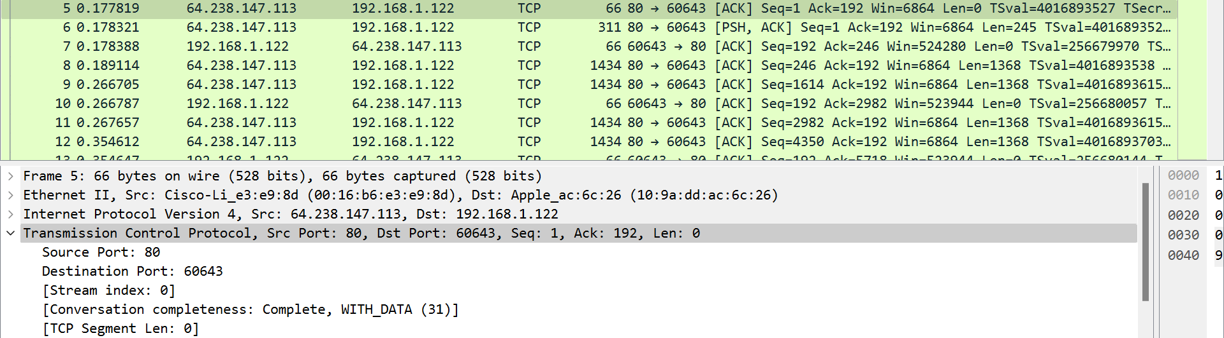

**Segment 6**

TCP segment Length: 245

**Segment 7:**

TCP segment Length: 0

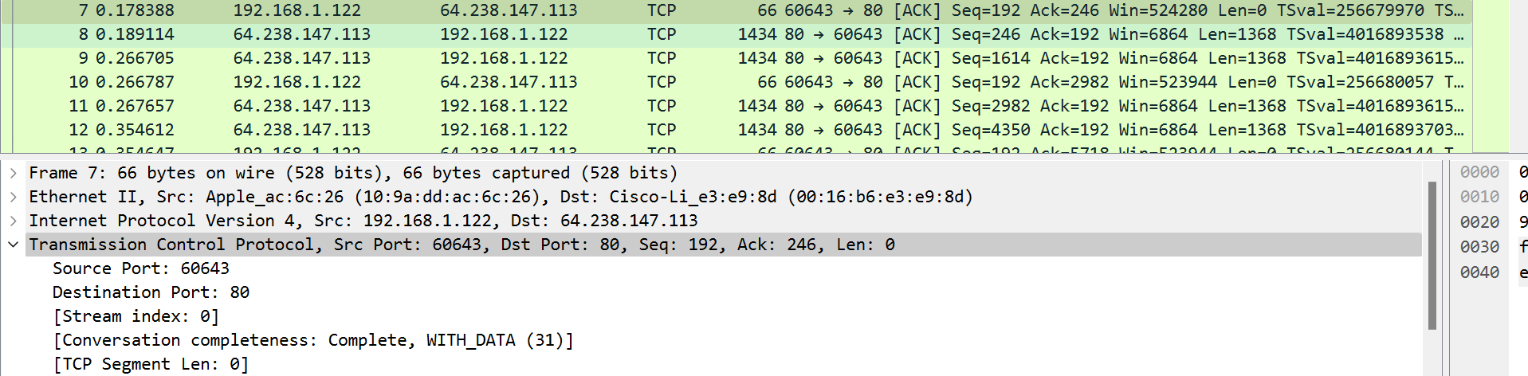

**Segment 8:**

TCP segment Length: 1368

**Segment 9:**

TCP segment Length: 1368

**Q5:**

**Are there any retransmitted segments in the trace file? What did you check for (in the trace) to answer this question?**

**ANSWER:**

The tracer file does not contain the transmitted segments. All of the sequence numbers are rising over time.